**LOCAL Dispatcher setup**

1. Go to the below url and download the file “httpd-2.2.25-win32-x86-no_ssl.msi ”

<http://archive.apache.org/dist/httpd/binaries/win32/>

1. Download the “dispatcher-apache2.2-windows-x86-4.1.11” dispatcher module from the below url.

<https://www.adobeaemcloud.com/content/companies/public/adobe/dispatcher/dispatcher.html>

1. Install the downloaded .msi file.
2. Extract the dispatcher module zip file into some location and keep it.
3. Now copy disp_apache2.2.dll to apache modules folder (eg. C:\Program Files\Apache Software Foundation\Apache2.2\modules)
4. Open apache httpd.conf file (eg. C:\Program Files\Apache Software Foundation\Apache2.2\conf\httpd.conf) and add the following line to include dispatcher configuration (added in next steps)

***Include conf/dispatcher.conf***

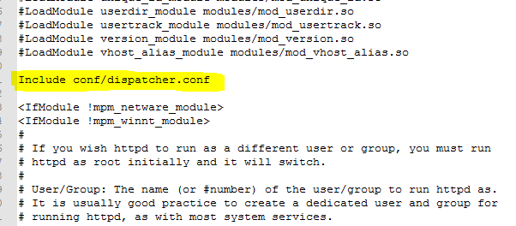

1. Create file dispatcher.conf in conf folder (eg. C:\Program Files\Apache Software Foundation\Apache2.2\conf\dispatcher.conf) and add the following configuration.

***LoadModule dispatcher_module modules\disp_apache2.2.dll***

***<IfModule disp_apache2.c>***

***DispatcherConfig conf/dispatcher.any***

***DispatcherLog    logs/dispatcher.log***

***DispatcherLogLevel 3***

***DispatcherNoServerHeader 0***

***DispatcherDeclineRoot 0***

***DispatcherUseProcessedURL 0***

***DispatcherPassError 0***

***</IfModule>***

***<Directory />***

***<IfModule disp_apache2.c>***

***SetHandler dispatcher-handler***

***ModMimeUsePathInfo On***

***</IfModule>***

***Options FollowSymLinks***

***AllowOverride None***

***</Directory>***

***Note :*** #1 loads the dispatcher module, #4 specifies the dispatcher rules file (created in next step)

1. Create file dispatcher.any in conf folder (eg. C:\Program Files\Apache Software Foundation\Apache2.2\conf\dispatcher.any) with the following configuration

***/farms {***

***/geometrixx-outdoors {***

***/clientheaders {***

***"*"***

***}***

***/virtualhosts {***

***"*"***

***}***

***/renders {***

***/rend01 {***

***/hostname "127.0.0.1"***

***/port "4503"***

***}***

***}***

***/filter {***

***/0001 {***

***/type "deny" /glob "*"***

***}***

***/0002 {***

***/type "allow" /url "/content*"***

***}***

***/0003 {***

***/type "allow" /url "/etc/designs*"***

***}***

***/0004 {***

***/type "allow" /url "/etc/clientlibs*"***

***}***

***}***

***/cache {***

***/docroot "C:/dev/code/install/Apache2.2/dispatcher/cache"***

***/rules {***

***/0000 {***

***/glob "*"***

***/type "allow"***

***}***

***}***

***}***

***}***

***}***

***Note :*** #2 is name of farm which could be any, #10 render is the publish instance serving pages to be cached (1:1 dispatcher to publish mapping recommended). #17 first denies access to every resource and making exceptions at #20 to allow resources under /content, #23 for allowing site css, #26 for js files, minimally needed for typical websites. #30 specifies the cache folder where static content generated from publish servers is cached for any future requests until any cached content is invalidated (next sections). Rule at #32 directs dispatcher to cache all content. For more indepth dispatcher configuration [check adobe documentation](https://docs.adobe.com/docs/en/dispatcher/disp-config.html)

1. With the above configuration in place, restart apache server, open a new browser instance and access the sample page on dispatcher running on default port 80 –<http://localhost/content/geometrixx-outdoors/en.html>  (Note You have to run the AEM publish instance)



1. The following statements should haven be logged in logs/dispatcher.log (Create a dispatcher.log file under logs folder Ex: C:\Program Files\Apache Software Foundation\Apache2.2\logs)

and also you can change the logs location at the “***DispatcherLog    logs/dispatcher.log***” at the dispatcher.conf file.

For reference :

<http://experience-aem.blogspot.in/2015/03/aem-6-sp2-simple-dispatcher-configuration.html>

**Creating a Localhost as a domain name**

Change the settings in the hosts file as below shown screenshot.

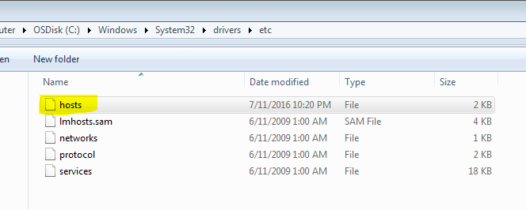

**Add entries of your like name as the domain names as shown below example.**

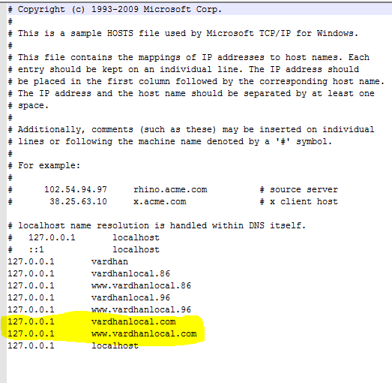

Access the project via the domain name as shown in the below screenshot. Your pages should be render as below.



Map the domain name with local dispatcher

Open the dispatcher.any file (if you have separated the farms related to module open the specific site related farm file in my case it is )

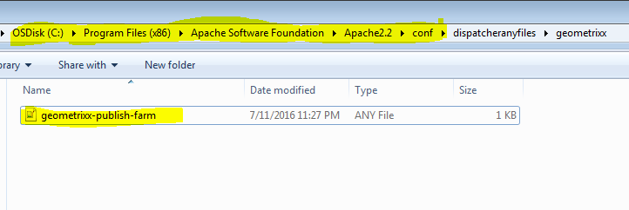

Make sure your virtualhost allows your domain name in the below screenshot “*” represents to allow all hosts.

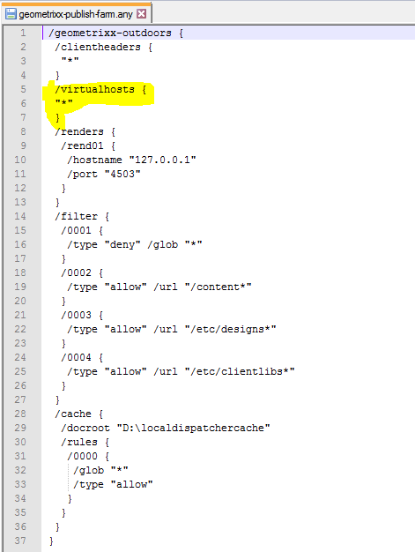

Else if you want to allow only the specific domain names specify as shown below.

Once you access via the domain name it will create a cache also



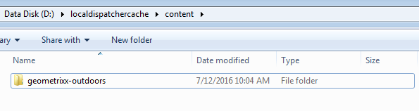

**Other domain names will not work as the virtualhost allows only specific domain name**

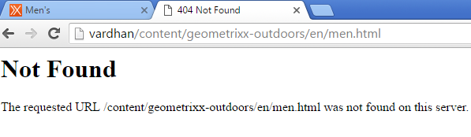

If we allow virtual host to all (i.e. *) then both the domains will work as shown below.



**Shortening of the URLS via the ETC maps**

ETC maps nodes screenshot as below you can use a third party developed plugin like below to generate a etc maps

<http://cognifide.github.io/Carty/>

attached the zip file here you can install in your AEM instance and generate the maps (generated maps sometimes might be wrong verify once according to the screenshots of etc/maps)



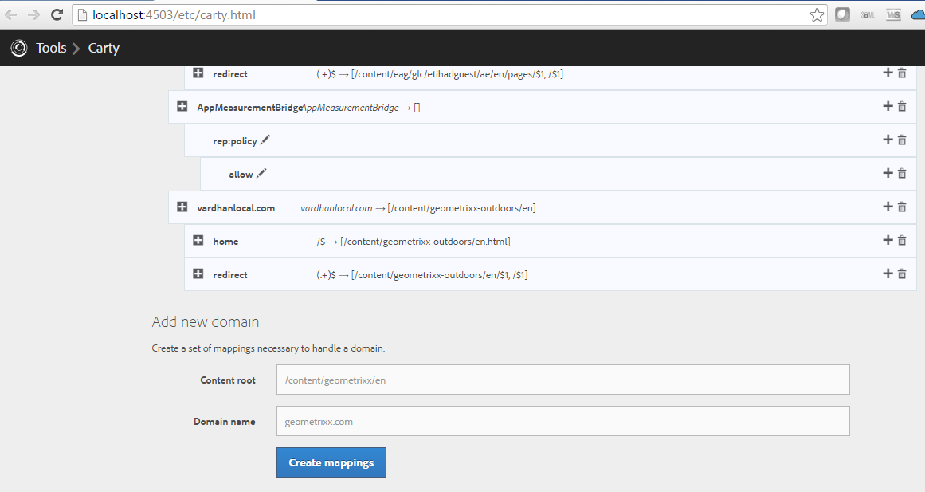

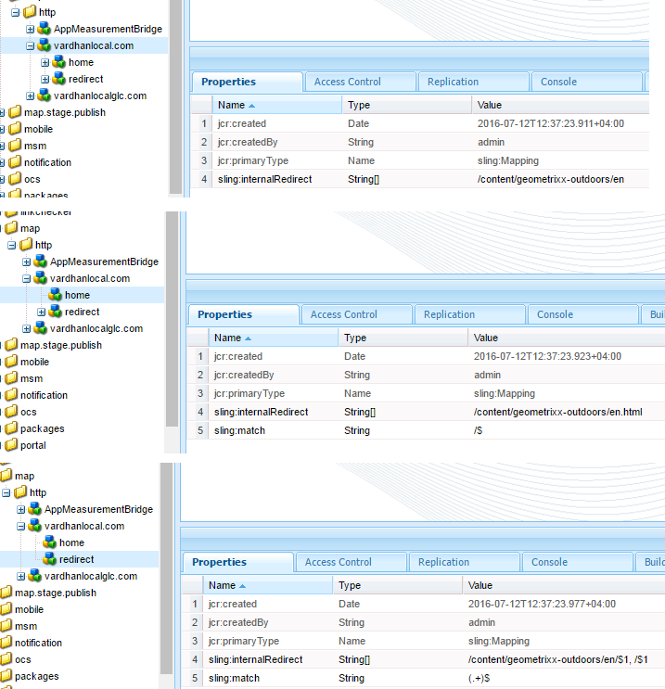

Add a virtual host entries in your dispatcher.any file or in a separate virtualhost file.

In my case I have added them in a separate file. And enabled the file include in the httpd.conf file. Also enable the rewrite module else virtualhost file enrty rewrite will not work.

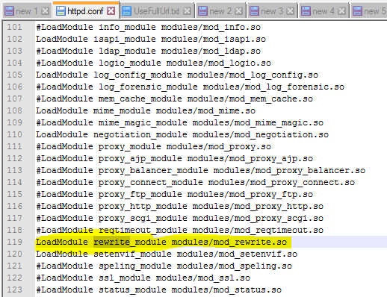

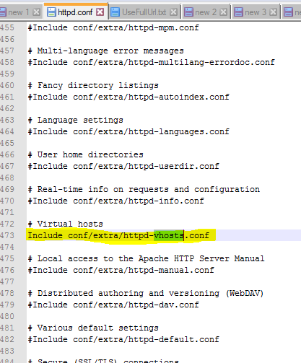

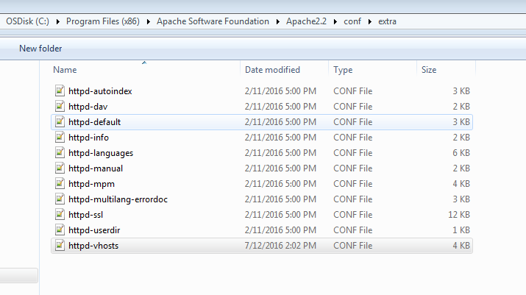

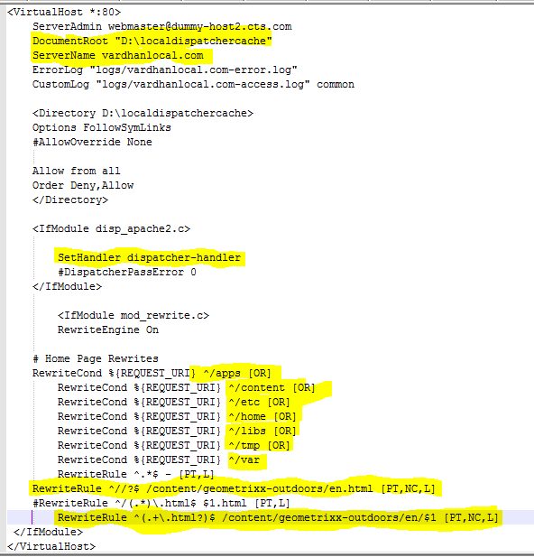

Make sure to pay attention on the highlighted rewrite rules and the SetHandler configurations, these are the crucial ones to render your page properly else the request might be stopped at dispatcher level itself not propagating to the publish instances of AEM.

That’s it once you done all the above configuration without any mistakes you should be able to see the domain name access of our home page. And all other pages should be rendered with short form of the urls by hiding the content paths that has been configured in etc/maps



